Plain HTML

📘 Definition
# Source: AI Source: Provided by: [Data Path: Persons Table -> ID Column: 1, Name_En Column: Motasem Essam] -> From: [ChatGPT] on [5/6/2026]
Plain HTML means writing a web page using only HTML code, without using any extra technologies like CSS (styling) or JavaScript (interactivity).
It focuses only on the structure and content of a web page.

🧱 What plain HTML looks like
# Source: AI Source: Provided by: [Data Path: Persons Table -> ID Column: 1, Name_En Column: Motasem Essam] -> From: [ChatGPT] on [5/6/2026]
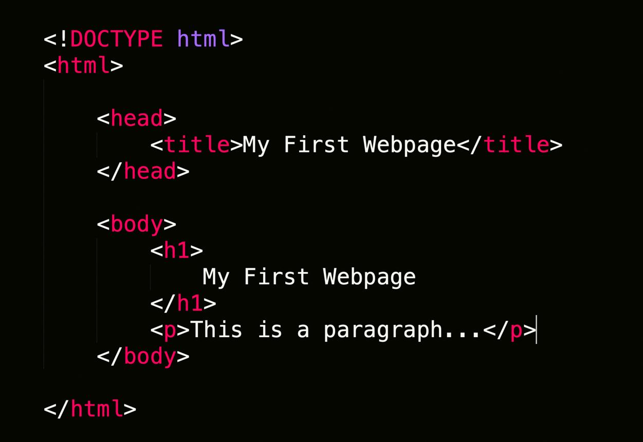
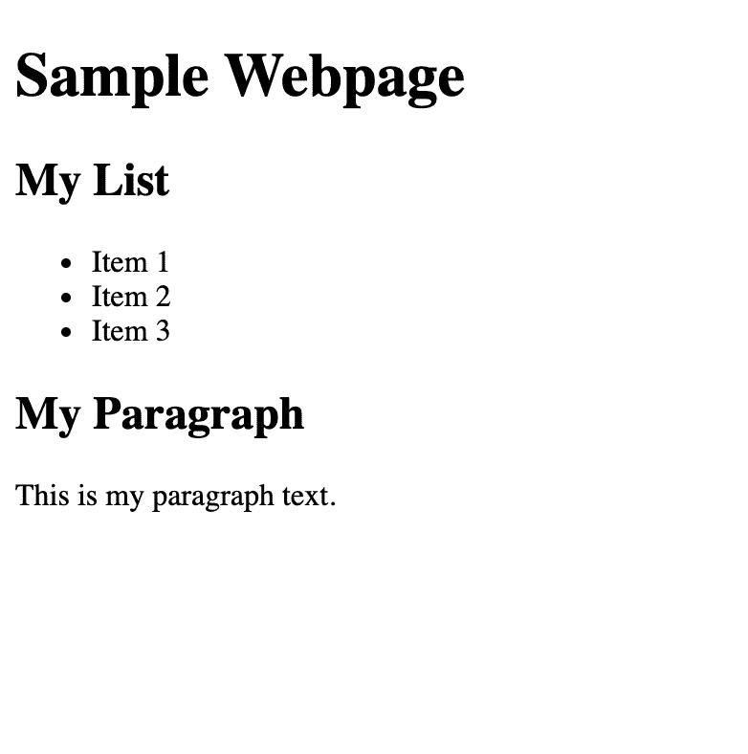
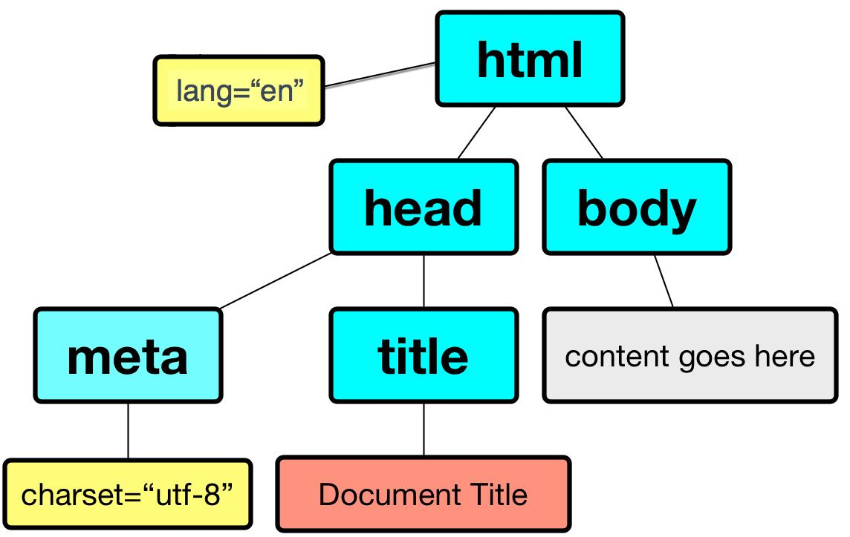
- Only HTML tags are used
- No colors, animations, or styling
- No buttons with effects or interactive behavior
- Just text, images, links, tables, forms

🧠 Simple example
# Source: AI Source: Provided by: [Data Path: Persons Table -> ID Column: 1, Name_En Column: Motasem Essam] -> From: [ChatGPT] on [5/6/2026]
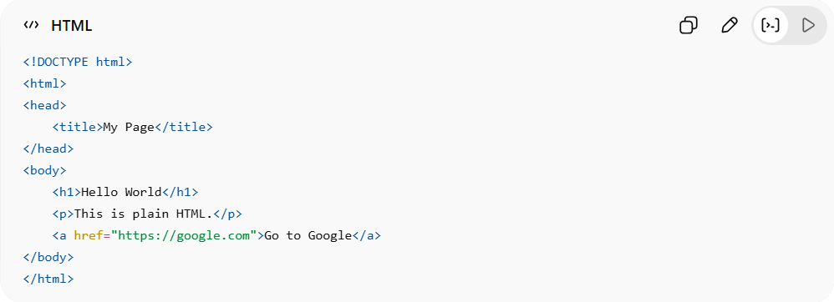
<!DOCTYPE html>
<html>
<head>
<title>My Page</title>
</head>
<body>
<h1>Hello World</h1>
<p>This is plain HTML.</p>
<a href="https://google.com">Go to Google</a>
</body>
</html>

🎯 Characteristics of Plain HTML
# Source: AI Source: Provided by: [Data Path: Persons Table -> ID Column: 1, Name_En Column: Motasem Essam] -> From: [ChatGPT] on [5/6/2026]
- 🧱 Only structure (no design)
- ⚪ Default browser appearance (white background, black text)
- ⚡ No CSS or JavaScript
- 📄 Easy to learn and understand

🧠 Simple analogy
# Source: AI Source: Provided by: [Data Path: Persons Table -> ID Column: 1, Name_En Column: Motasem Essam] -> From: [ChatGPT] on [5/6/2026]
Think of:
- 🏠 Plain HTML = house structure (walls, rooms)
- 🎨 CSS = paint and decoration
- ⚙️ JavaScript = electricity and smart features

🌐 Where plain HTML is used
# Source: AI Source: Provided by: [Data Path: Persons Table -> ID Column: 1, Name_En Column: Motasem Essam] -> From: [ChatGPT] on [5/6/2026]
- 📚 Learning web development basics
- 🧪 Testing simple web pages
- 🧑‍💻 Early stage prototypes
- 📄 Static information pages

🚀 In short:
# Source: AI Source: Provided by: [Data Path: Persons Table -> ID Column: 1, Name_En Column: Motasem Essam] -> From: [ChatGPT] on [5/6/2026]
Plain HTML = a basic web page made only with HTML, without styling (CSS) or interactivity (JavaScript).

